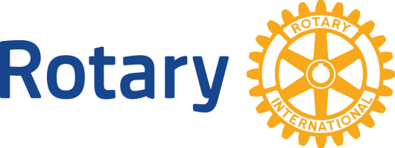 | Rotary International  District 7080  Million Dollar Dinner
A celebration dinner thanking those who support our campaign to raise USD $1 million dollars to enable the program and project work of the Rotary Foundation
(for gifts made from 1 January 2018 to 6 May 2019)
Thank you for taking action that improves communities … with your gift of support to our Rotary Foundation!
There are many like you that truly make a difference with major financial support to the Rotary Foundation (rated 4 out of 4 stars by Charity Navigator **) and six areas of focus … Water and Sanitation, Maternal and Child Health, Basic Education and Literacy, Peace and Conflict Prevention and Resolution, Disease Prevention and Treatment, and Economic and Community Development.
What does your gift to the Rotary Foundation accomplish?
Well that depends on what is most important to you! Your support is invited through an outright Major Donor gift*, Arch Klumph Society Gift* or Bequest Society gift*. If already a donor, please consider an increased gift of support to your current Bequest, Benefactor or Major Donor Gift levels. Your own personal named fund may be established within Rotary’s endowment with any outright or gift commitment of USD$25,000**. Gifts may be directed towards:
- Polio Eradication - which includes the Gates 2:1 match!
- Annual Programs**- shared gift split 50/50 between World Fund and your district … to enable district activities for both local and international projects. (if endowed, will gift out in perpetuity)
- World Fund** - an unrestricted gift for the greater good of Rotary as determined by the Trustees of the Rotary Foundation.
- Rotary Peace Centers** - Rotary’s highest educational priority. Your gift will fund our Peace Fellows at one of our 7 premier global institutions of learning partners.
- Any of Rotary’s Six area’s of focus which include: Water and Sanitation, Disease Prevention and treatment, Maternal and Child Health, Economic and community development, Basic education and Literacy and Peace.

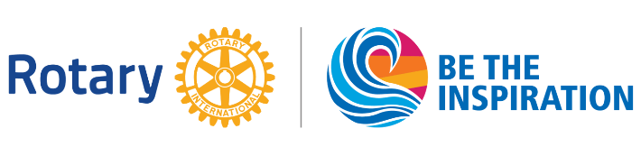
Please make a gift of support … and be a guest at the Million $ dinner!
You are invited to consider the gift options listed below. For more information and to formalize your gift, please complete the below form and return it to your planning committee or send to:
John Gilvesy, District Governor - Tel. 1 (519) 688-8049 / Email jgilvesy@gmail.com
Carolyn Ferguson, Zone 24 Senior Major Gifts Officer | Polio, Development & Partnerships – Tel .1 (289) 522-0270, Email: Carolyn.Ferguson@rotary.org
____________________________________________________________________________
Yes, I want to be a guest with this gift.
Name (individual or joint as couple): __________________________________________
District:_______________ Club:___________________________________
Address: _____________________________________________
Email + Phone _________________________________________
Gift Designation/Program ___________________________________
I have made or will make a bequest gift to the Rotary Foundation (Canada) in the amount of USD$______________ and have completed or will complete the required paperwork by 6 May, 2019.
I have an existing benefactor or bequest gift commitment that I would like to increase to qualify for attendance at this event for a total of USD$______________
I have a life insurance policy that I would like to name the Rotary Foundation (Canada) as a beneficiary to become a Bequest society member valued at USD $____________________
I would like to make an outright or 3-year pledged Major Donor gift of USD $______________ by cheque, credit card or direct gift of publically traded securities.
Please contact me regarding other considerations.
**The Rotary Foundation is a not-for-profit corporation funded solely by voluntary contributions from members and friends of Rotary who support its mission to advance world understanding, goodwill, and peace. Using Rotary Foundation grants, Rotary's 34,000 clubs across the globe develop and carry out sustainable humanitarian projects and provide scholarships and professional training opportunities that promote peace, fight disease, provide clean water, sustain mothers and children, improve education, and strengthen local economies. The Foundation is a worldwide leader in the efforts to eradicate polio through its partnership with the World Health Organization, UNICEF, the U.S. Centers for Disease Control and Prevention, and the Bill & Melinda Gates Foundation. When Rotary launched its PolioPlus program in 1985, more than 350,000 people were afflicted with polio each year, and the disease was endemic in more than 125 countries. Since 1988, Rotary and its partners in the Global Polio Eradication Initiative have immunized over 2.5 billion children, reducing the incidence of polio by 99 percent and eradicating it from all but three countries. Rotary has contributed more than $1 billion and many thousands of hours to eradication effort. The Foundation also funds the training of hundreds of peacemakers through the Rotary Peace Center program, which enables fellows to pursue a master's degree or professional certificate at one of Rotary's partner universities. Through academic training, study, and practice, the fellows become leaders who promote peace and aid conflict resolution in their communities and around the world.
For the 10th consecutive year, The Rotary Foundation has received the highest rating — four stars — from Charity Navigator, an independent evaluator of charities in the U.S. In the most recent ratings, the Foundation earned the maximum of 100 points for demonstrating both strong financial health and commitment to accountability and transparency. In a letter to the Foundation, Charity Navigator notes that "only 1 percent of the charities we evaluate have received at least 10 consecutive 4-star evaluations, indicating that The Rotary Foundation outperforms other charities in America. This exceptional designation from Charity Navigator sets The Rotary Foundation apart from its peers and demonstrates to the public its trustworthiness." The rating reflects Charity Navigator's assessment of how the Foundation uses donations, sustains its programs and services, and practices good governance and openness. https://my.rotary.org/en/foundation-receives-highest-rating-charity-navigator

