Email from Piotr D. Kaczorowski – May 18/22
President Rotary Club of Warsaw, est. 1931
Report on the Rotary Warsaw Cluster Fund – Help for Ukraine

Dear Rotary Friends and Donors!

Once again thank you for your generous contribution. You support our joint Rotary work.

As you might know since February 24, the day of the beginning of Russia's aggression, 3.4 million refugees from Ukraine have already crossed the Polish-Ukrainian border.

Thanks to your generous donations, we are constantly implementing projects to help refugees from Ukraine.

Below we present projects from the last 48 days (April and May until today):

I. Small projects

Project #1
- status: COMPLETED
- beneficiary: shelter for refugees at Wilcza Street in Warsaw
- amount: 2150 PLN / 485 USD / 461 EUR
- date: 8.04.2022
- description: clothes for 38 children

Project #2
- status: COMPLETED
- beneficiary: mother + older daughter and triplets (girls)
- amount: 500 PLN / 110 USD / 104 EUR
- date: 9.04.2022
- description: accommodation for a family (4 person) from Ukraine in Białystok, who traveled through Belarus to Poland - destination accommodation in the Klub Sosnowy (The Pine Club) resort in Warsaw

Project #3
- status: COMPLETED
- beneficiary: refugee center in the northern part of Warsaw (Białołęka)
- amount: 250 PLN / 55 USD / 52 EUR
- date: 9.04.2022
- description: purchase of cleaning products for the refugee center in Białołęka

Project #4
- status: COMPLETED
- beneficiary: refugee center in Tomice near Baniocha (Piaseczyński poviat)
- amount: 2000 PLN / 450 USD/ 427 EUR
- date: 9.04.2022
- description: purchase of basic medicines for over 40 refugees from Ukraine

Project #5
- status: FOLLOW-ON
- beneficiary: Religious House of the Sisters of Mary
- amount: 2000 PLN / 450 USD / 427 EUR
- date: 11.04.2022
- description: 17 people (2 families with one disabled child: 3 adults, 14 children); needs: food, cosmetics and cleaning products, shoes, prepaid card for mobile phone)

Project #6
- status: COMPLETED
- beneficiary: SOS Wioski Dzieciece Foundation - help for children from Ukraine - cooperation with Hotel Raffles Europejski Warsaw
- amount: 2000 PLN / 450 USD / 427 EUR
- date: 26.04.2022
- description: participation during charity night - future cooperation in common projects also with new refugee center and psychological clinic for children from Ukraine (Warsaw surroundings)

Project #7
- status: FOLLOW-ON
- beneficiary: Religious House of the Sisters of Mary
- amount: 2000 PLN / 450 USD / 427 EUR
- date: 3.05.2022
- description: 17 people (2 families with one disabled child: 3 adults, 14 children); needs: food, cosmetics and cleaning products, shoes, prepaid card for mobile phone)

Project #8
- status: COMPLETED
- beneficiary: temporary orphanage in Nadyby 40 km from the Ukrainian-Romanian border
- amount: 2000 PLN / 450 USD / 427 EUR
- date: 11.05.2022
- description: 30-50 children from 3 to 12 years old found on the streets of towns and villages near Kyiv, which were destroyed by the Russian army and from Mariupol. There is a constant rotation of children in the center. We provided mainly specialized food (mainly modified powdered milk) for young children and sweets for the elderly. You will also need sheets and bedding sets as well as personal hygiene items and food.
- extra info: this project is outside of our typical area of operation but it was cooperation with transport based on our Rotary logistic center in Warsaw

Project #9
- status: COMPLETED
- beneficiary: Fundację Oczami Nieba - Domowa Noclegownia na Łazienkowskiej (Home Night shelter in Łazienkowska hosted by Through the Eyes of Heaven Foundation)
- amount: 2000 PLN / 450 USD / 427 EUR
- date: 11.05.2022
- description: food, household and hygiene products for 35 people from Ukraine during 7 days period

Project #10
-status: FOLLOW-ON / IN PROGRESS
- beneficiary: Fundację Oczami Nieba - Domowa Noclegownia na Łazienkowskiej (Home Night shelter in Łazienkowska hosted by Through the Eyes of Heaven Foundation)
- amount: 2000 PLN / 450 USD / 427 EUR
- date: 18.05.2022
- description: food, household and hygiene products for 35 people from Ukraine during 7 days period

Total budget: 16 900 PLN / 3 817 USD / 3 629 EUR
We assume that the projects helped about 120 people.
II. Refugee center in cooperation with The Pine Club (Klub Sosnowy), Rotary Club of Warsaw, Anglican Church:
- status: IN PROGRESS
- funds transferred to date: 104 670 PLN / 23 635 USD / 22 475 EUR
- segment: accommodation + food
- description: We have completed refinancing: for 1385 person-nights, with average 7 days for person, we were able to help about 200 people (mainly children with mothers)
- extra info: we have a deal with Anglican Church: we do all in co-financing 50/50 and message from our friend Peter Świecicki (friend of John Hewko):
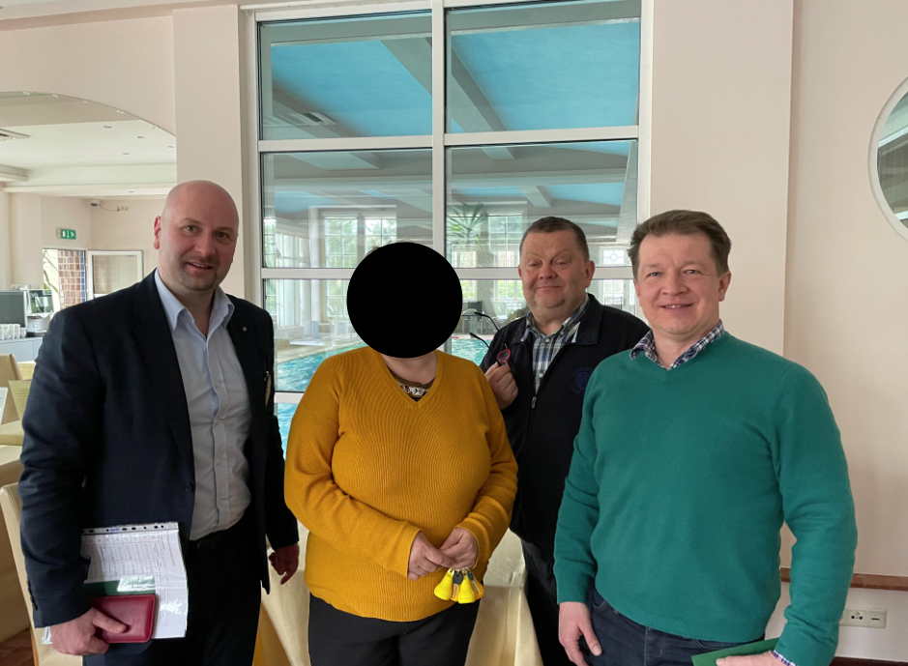
(We were asked not publish faces of refugees)
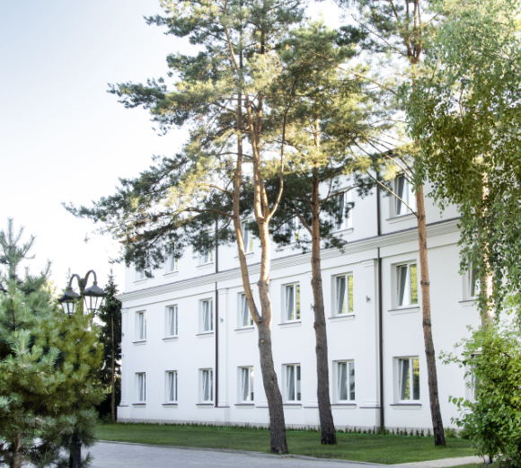

III. Logistic hub "Warsaw" hosted by Rotary Club of Warsaw and non-equity projects
Project #11
- date: 29.03.2022
- delivering drinks, snacks, cookies, candies, diapers, handkerchiefs, coffee, milk, disinfectants, garbage bags, kitchen paper to the Warsaw West Railway Station,

Project #12
- date: 30.03.2022
- delivery of medicines to Lviv

Project #13
- date: 30.03.2022
- a stroller for an elderly person - Mrs. Lidia from Kharkiv

Project #14
- date: 1.04.2022
- "aid action" heart for Ukraine "- food and household chemicals - transferred to Lviv

Project #15
- date: 6.04.2022
- transport of 20 refugees from Warsaw (and other parts of Poland) to Sweden

The dinner the day before transport:

Project #16
- date: 7.04.2022
- receiving goods from the Rotary Club Calpe Ifach from Spain and transporting 15 refugees from Ukraine to Spain
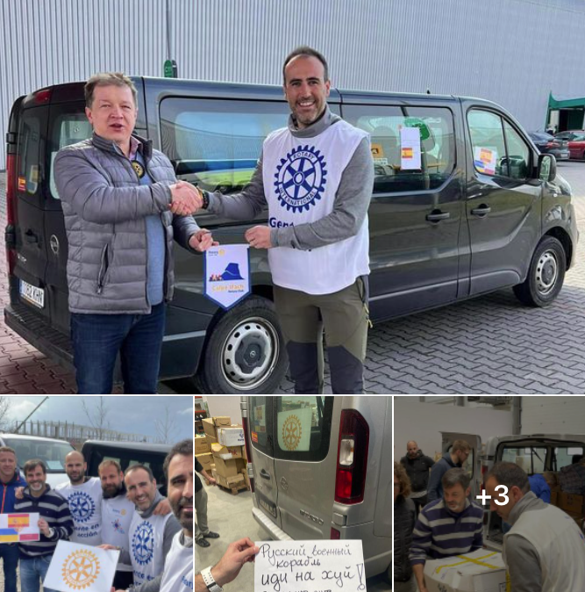
Project #17
- date: 10.04.2022
- three cars full of goods went to the Warsaw Expo at Modlińska Street in Warsaw (Warsaw City refugees camp)
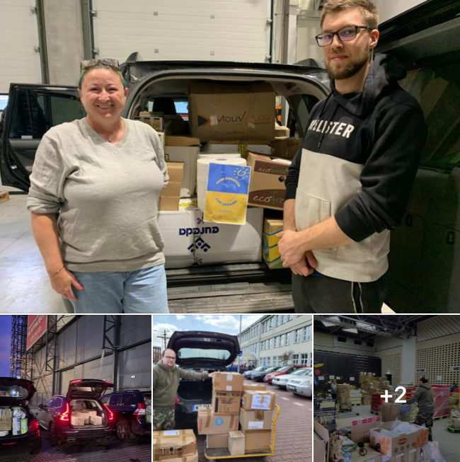
Project #18
- date: 13.04.2022
- medical products delivered to Kiev and Lviv

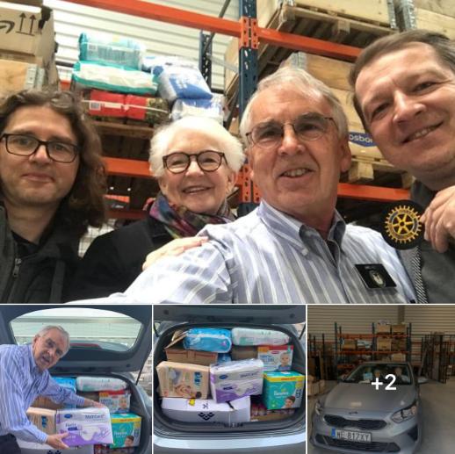

Project #19
- date: 29.04.2022
- received to Logistic hub "Warsaw" to further distribution: medicines, hygiene products, food, blankets, baby care products, diapers etc. The donor is Rotary International - District 1700 and the Pierre Fabre Group.

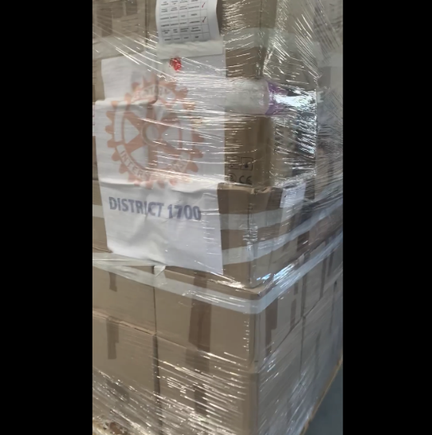

Project #20
- date: 9.05.2022
- transport with goods delivered to Kiev
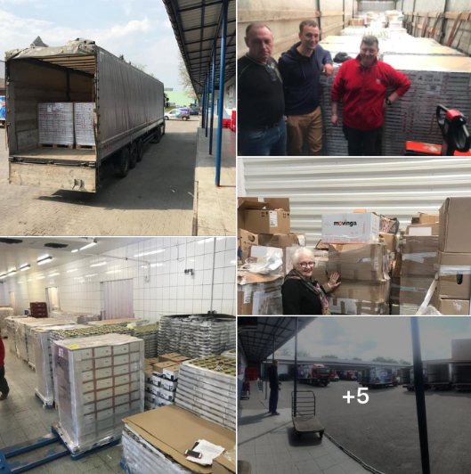

Project #21
- date: 13.05.2022
- transport to the center for war refugees from Ukraine located in the Kaputy sports hall in Ożarów Mazowiecki

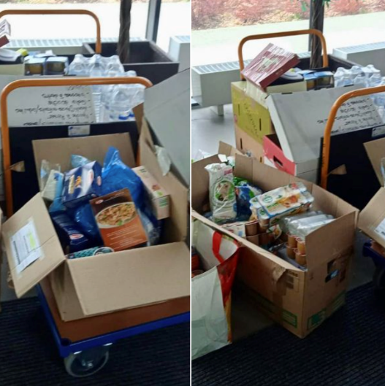

IV. Start of cooperation with the Warsaw City
- date: 18.05.2022 (agreement date: 13.05.2022)
- formalities related to obtaining a job, financing medical check
- beneficiary: 200 women/mothers from Ukraine
- amount 30000 PLN / 6773 USD / 6444 EUR

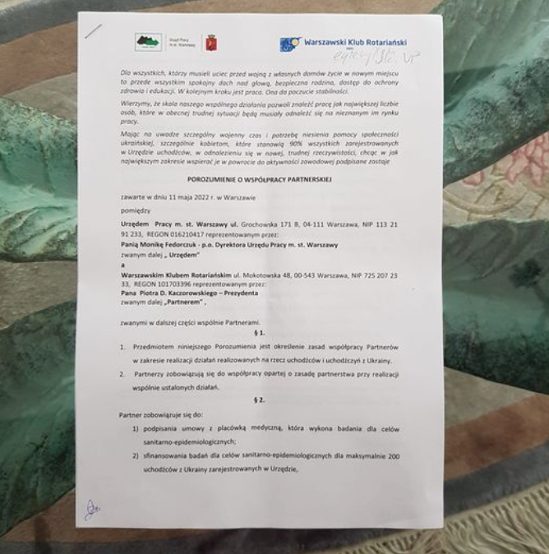

V. Summary:

- Last 48 days
During last 48 days, we helped about 320 people using: 121 570 PLN / 27 452 USD / 26 105 EUR.
Only one small project was outside our assigned area of operation.

- The next big project:
Today we started project with Warsaw City that will help next 200 people from Ukraine.
This gives us the total help provided by Rotary Club's Cluster "Warsaw" for 520 people. They are mainly children and mothers.

Please remember that WE = Rotarians in Warsaw and YOU as DONORS.

VI. Forecast and area of focus

Considering that we mainly help children and women, the following are important all the time:
(a) accommodation, food and medicines (both: children and women)
(b) job search and adaptation to the new environment (women)
(c) we are starting to implement education for children (children)

Our calculations show that for accommodation, food and medicine alone, we are able to address a budget of about 100k PLN / 22.5k USD / 21.5k EUR per every month. For (b) area we are able to address a budget of about 30k PLN / 6.7k USD / 6.5k EUR. We can even double this budget.

Soon we will do forecast for (c) and we'll cover more in the next letter on this area.

VII. As a reminder, I would like to provide still up-to-date information about us:

ROTARY CLUB'S CLUSTER WARSAW: HELP FOR UKRAINE - Aid Strategy:
Chapter 1:
- transport
- food
- accommodation
- formalities
- basic needs
Chapter 2:
- find a job
- children education
- new env. adaptation

Region of operation: Warsaw City Area and its surroundings

Current methods of Contribution

PayPal:
https://paypal.me/rotarywarsaw

Also in very traditional way:

Address of Rotary Club of Warsaw (aka RC WARSZAWA):
Warszawski Klub Rotariański
ul. Mokotowska 48
00-543 Warszawa

Preferable new account:
IBAN: PL38114020040000330282278650
BIC: BREXPLPWMBK
BANK: mBank SA

Validation:
https://www.ibancalculator.com/iban_validieren.html

